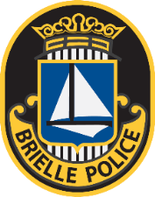
DEPARTMENT OF POLICE
BOROUGH OF BRIELLE
Session 273

GARY J. OLSEN CHIEF OF POLICE

RECORD REQUEST UNDER COMMON LAW

NAME:

ADDRESS:

DATE OF INCIDENT:

TYPE OF INCIDENT:

I certify that I am a party to the requested records and am entitled to the records under Common law. I further certify that the requested documents are for legitimate interests only and that the information will not be further transferred or communicated to any unauthorized party.

DATED:

PRINT NAME

DATED:

SIGNATURE

601 Union Lane ~ P.O. Box 445 ~ Brielle, New Jersey 08730 ~ (732)528-5050 ~ Fax (732)528-5057
www.briellepd.org

